Exp 39

AIM: Design DFA using simulator to accept the string the end with abc over set {a,b,c)

W= abbaababc

INPUT:

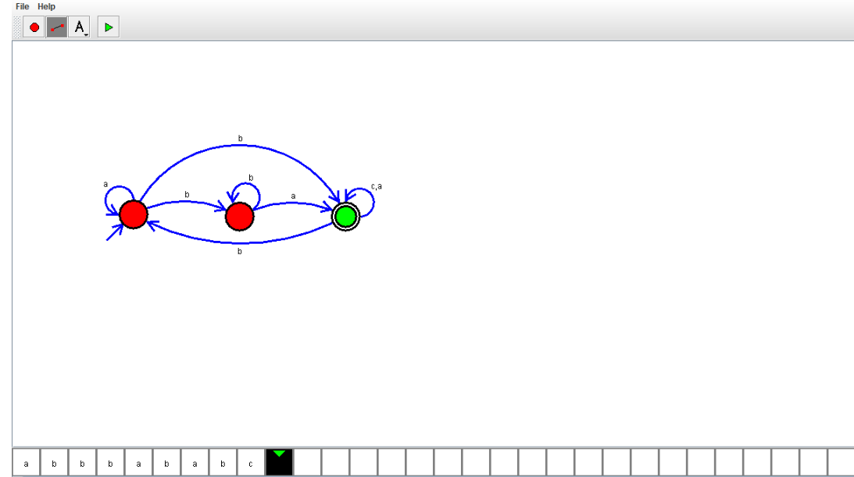

OUTPUT:



RESULT:

Design DFA using simulator to accept the string the end with abc over set {a,b,c) is verified